VOCC

From Kathi’s smooth muscle cell (SMC) model

Where

|  |  |
| --- | --- |
| Parameter | Value |
|  | 1.2x10-3 M mV-1s-1 |
|  | 100 mV |
|  | -24mV |
|  | 8.5 mV |

And V is the membrane voltage. This becomes a part of both the rate of change of calcium and the rate of change of membrane potential equation. Thus that the cell which was previously governed by:

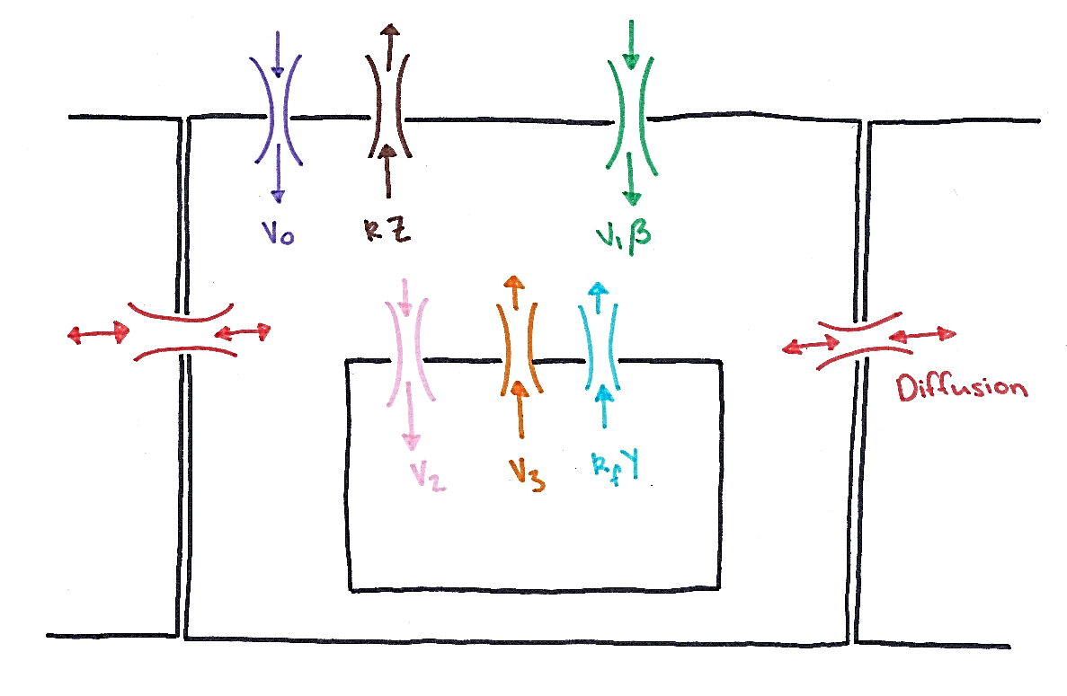

Calcium Store

Now becomes

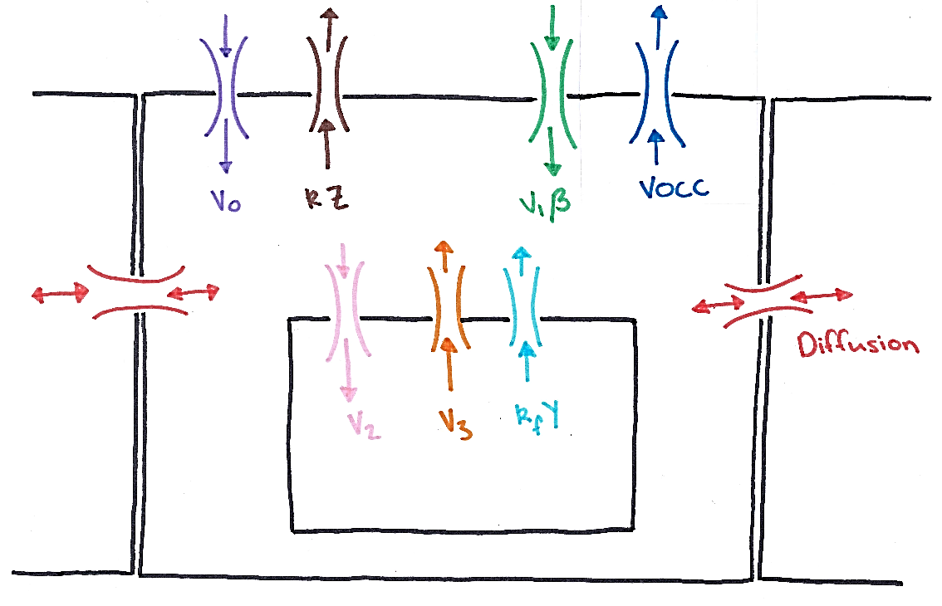

Calcium Store

# Zero Diffusion

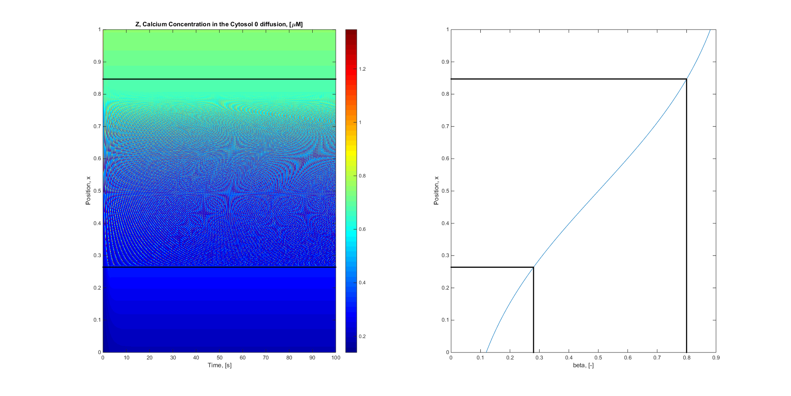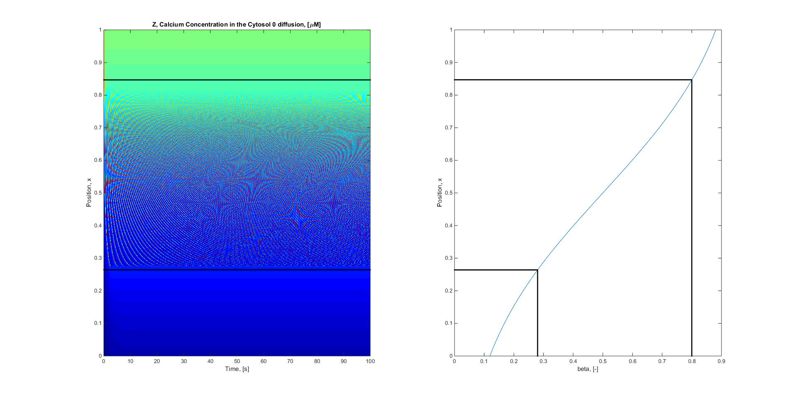

**With VOCC**

# Fickian Diffusion (D = 6e-6)

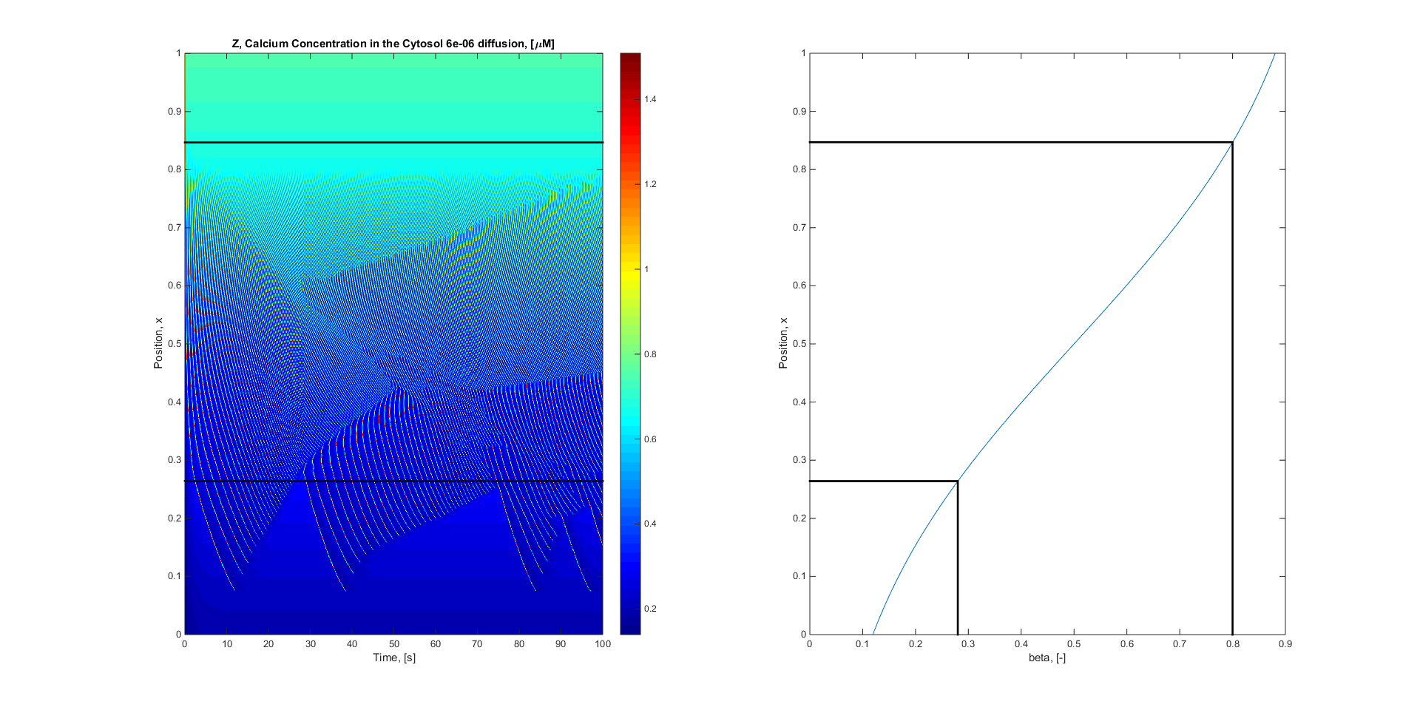

**With VOCC**

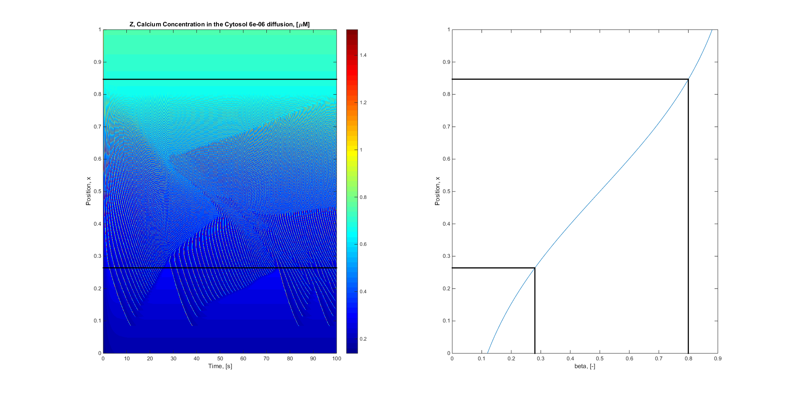

# Electro Diffusion (D = 6e-6)

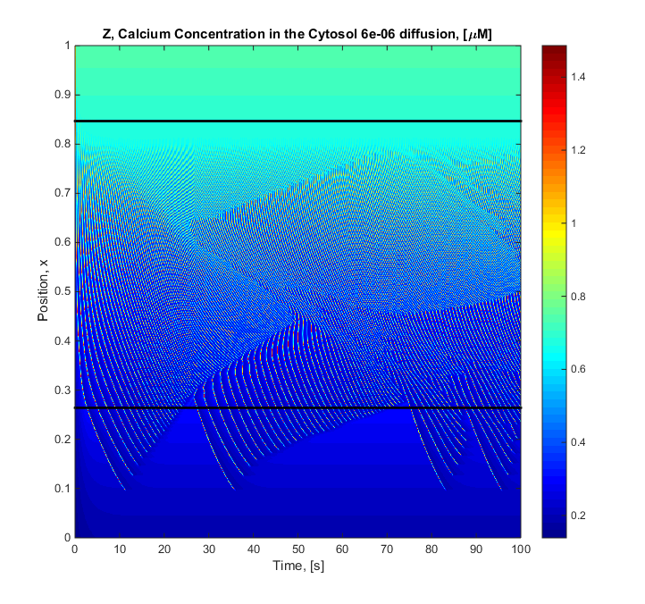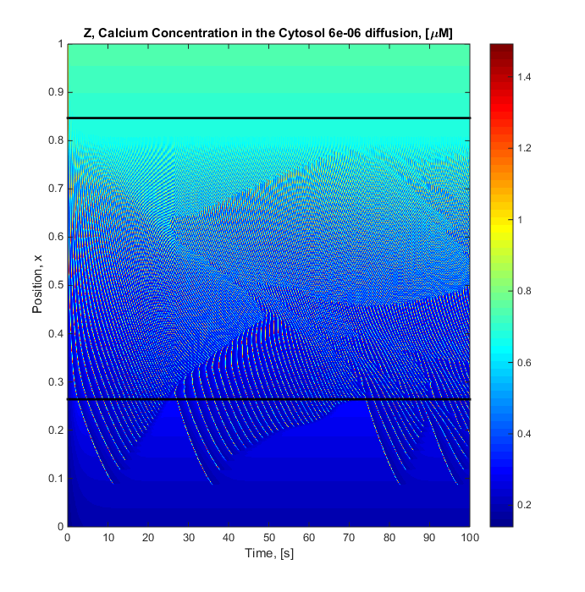

**With VOCC**